**Expert ID/Name: Nstructive**

**Date:**

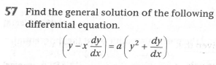

**Answer:**

|  |
| --- |
| **Section 1:** Algorithm/Theorem Reminder / A tip for solving these type of questions |
| **Tips:**   1. Separate the terms of. 2. . |

|  |
| --- |
| **Section 2:** Step-by-step answer |
| Given: Differential equation is ,  To find: General solution of  Step 1:   |  |  | | --- | --- | | Instruction | Separate the terms of . | | Calculation |  |   Step 2:   |  |  | | --- | --- | | Instruction: | Apply the integration on both sides with respect to x. | | Calculation: |  | |

|  |
| --- |
| **Section 3:** |
| Final answer: General solution of differential equation is .  Hence, verified. |